Instructions for Bidding in SRM

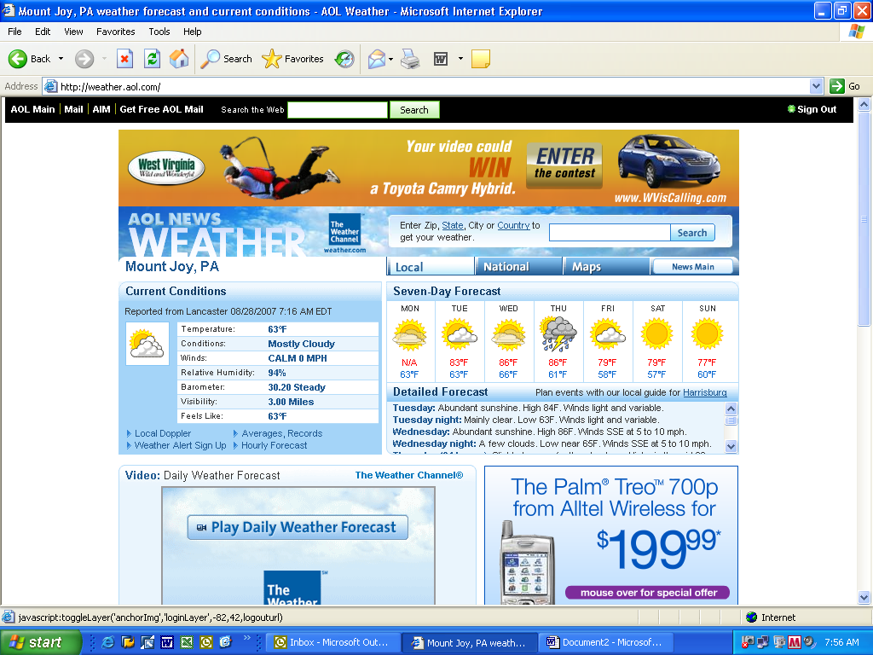

- Do NOT use your Internet Browser’s Back button while in SRM.

- Do NOT use the Red X to close SRM. Use of these will abruptly end SRM with possible loss of data.

Important Note: If you are entering several line items, it is good practice to click the Refresh and then Hold buttons to save the work that you have done. If you have a problem with your computer, the work you have placed on hold will be saved. To return to your work, click the Change button (this will appear only when your document is on hold).

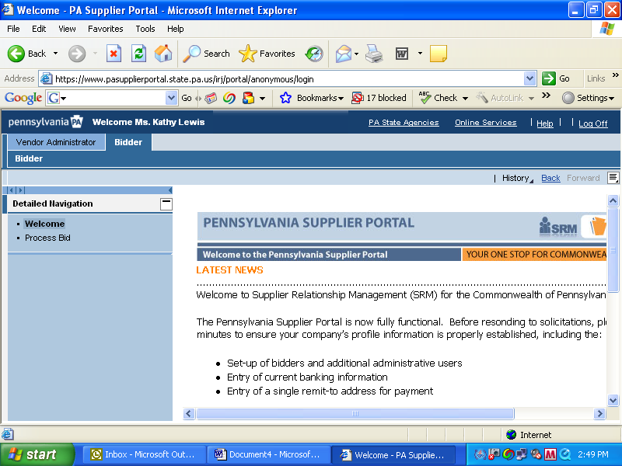

Log on to www.pasupplierportal.state.pa.us and enter User Name and Password. Once in the portal, make sure you click on the ‘Bidder’ tab then click Process Bid.

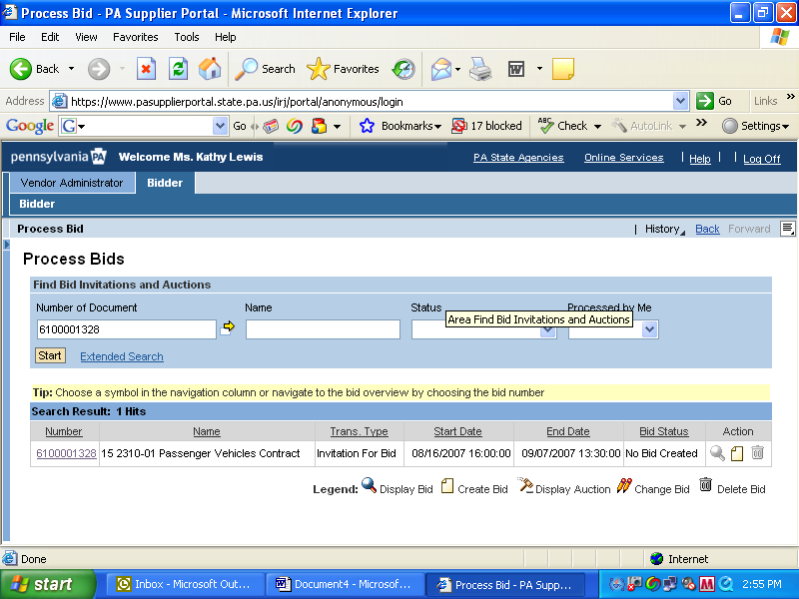

Insert Bid Number (you can obtain this through www.portal.state.pa.us) then click the Start button.

Click on Bid Number (hyperlink).

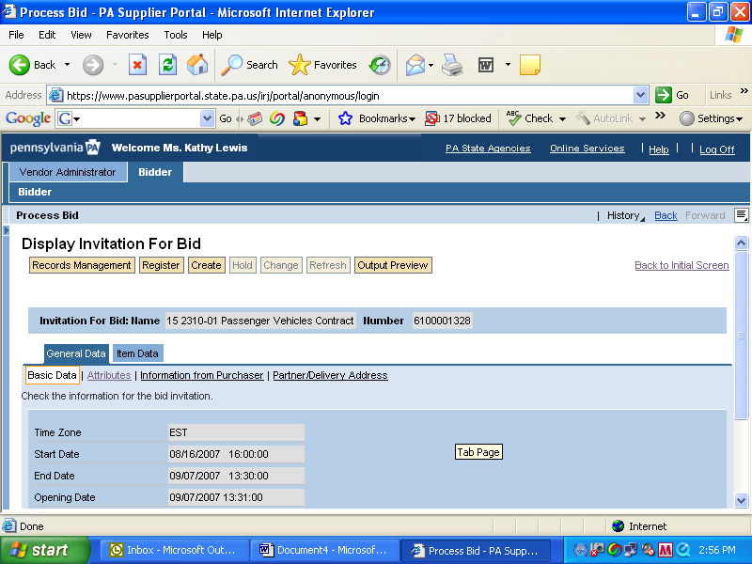

Once the Display Invitation For Bid opens click the Create button.

Note: You are under the General Tab.

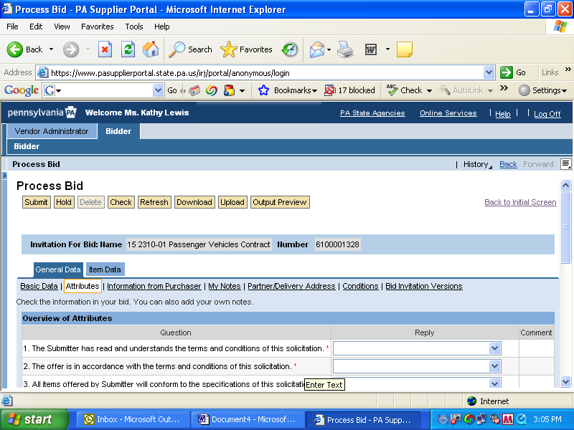

Notice the screen changed from the Display mode to the Process Bid mode – the Attributes automatically come up. You must respond to ALL of the Attributes questions.

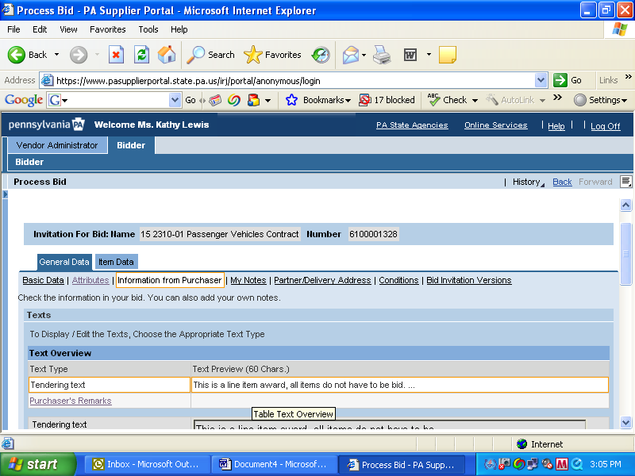

After all Attribute questions are completed, click the General Data Tab then click Information from Purchaser.

See next slide – continued.
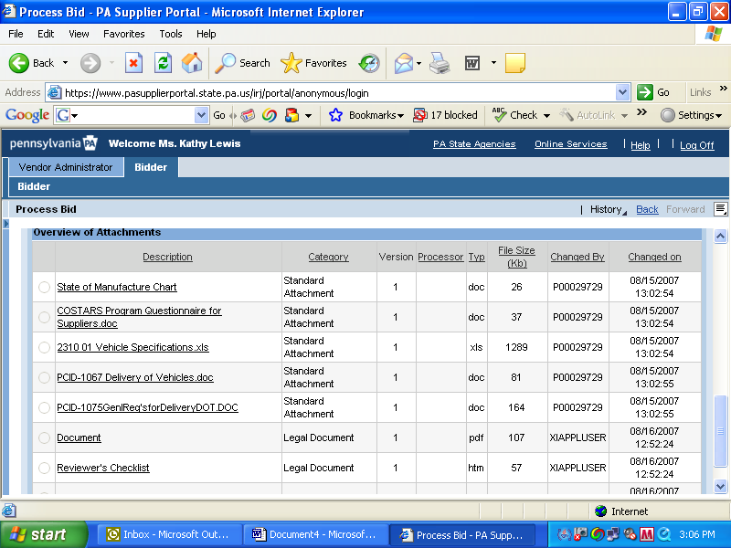

It is your responsibility to check for Flyers posted to the IFB.

To download the attachments – click on the document (opens up in Word format) and save the document to your computer desktop.

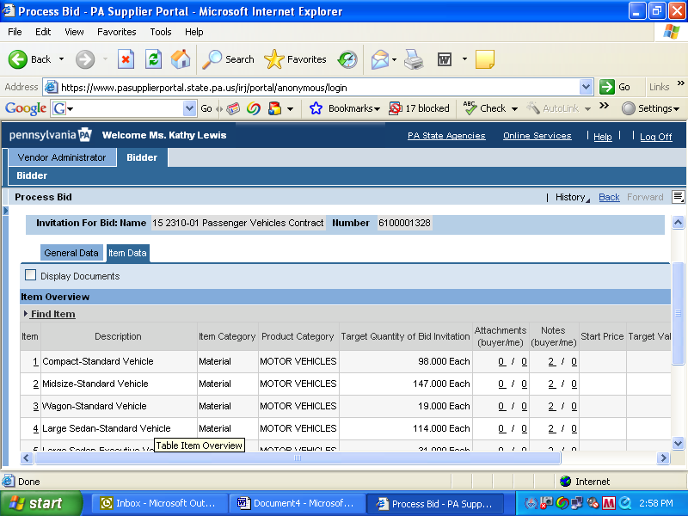

Click the Item Data Tab.

See next slide – continued.

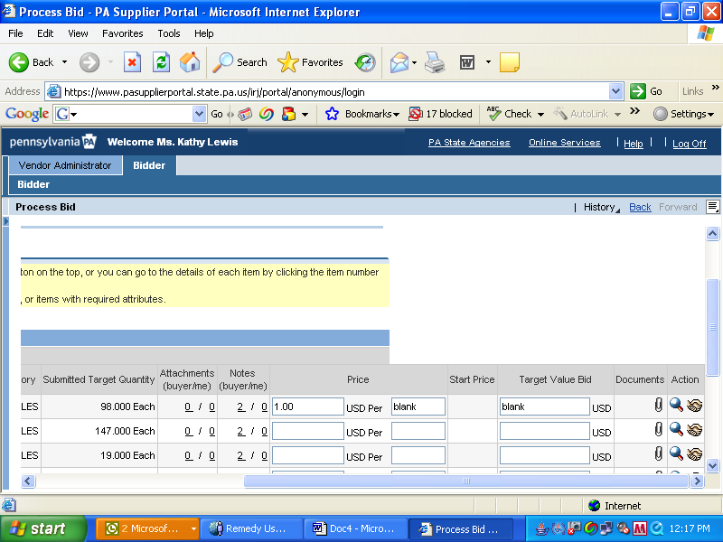

Enter line item price.

Do NOT enter anything in the USD Per Block. We listed blank in the box for reference only.

Do NOT enter anything in the Target Value Block. We listed blank in the box for reference only.

When you have entered the first line item pricing, click the Refresh then Hold Buttons (this will save all that you have completed thus far). You must then click the Change Button to continue.

Click magnifying glass to enter your make/model/trim

See next slide.

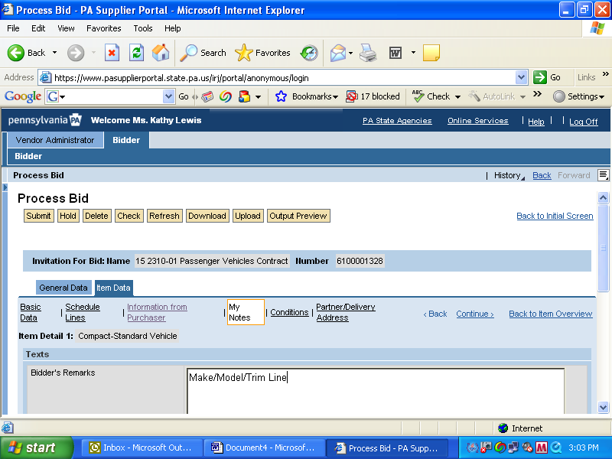

Click on My Note and enter your Make/Model/Trim Line.

Select Continue if you want to enter more line items.

Item Detail identifies what line item you are on.

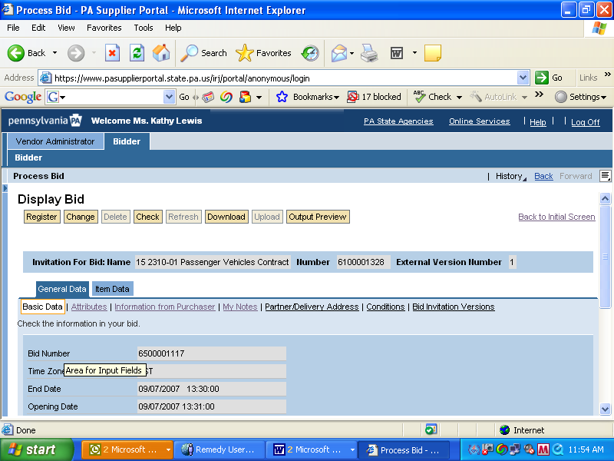

Once you have completed entering all the line items you want to bid, click on the General Data Tab.

Click on My Notes to upload attachments that you saved to your computer.

See next slide…
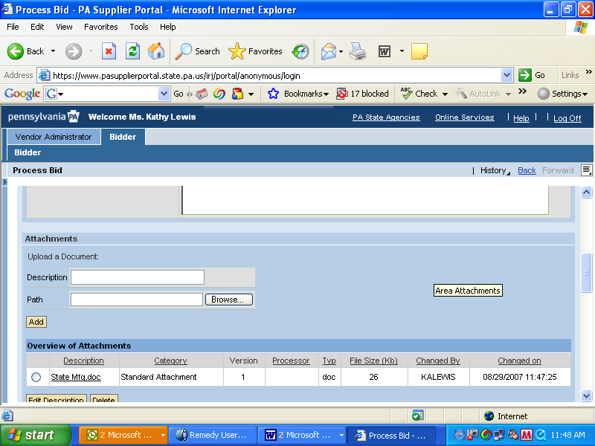

Under My Notes is where you will upload any document(s) that you saved to your computer.

Click on the Browse button to locate your attachments on your computer, and then click open.

It will populate in the “path” field.

Then you NEED to click the ADD button to have them attach to the IFB.

After you feel comfortable with your pricing and uploading your attachments, then all you have left to do is click the submit button….

Good luck!!!!!!!!!!!!!!!!!!!

